Updates and Announcements
Thank you for worshiping with us at Bethel United Methodist Church! We are delighted you have chosen to worship with us this morning.

This Week
Tuesday – Prayer Meeting at 9:30 am via Zoom
Lenten Book Study - Words of Life at 7pm via Zoom

Upcoming:
Midday Community Holy Week Services at York Place each day 3/29 to 4/2 at noon.
Maundy Thursday Service 4/1/21 at 6pm at Bethel.
Good Friday Service 4/2/21 at 6pm at Philadelphia.

Worship Servants - Lay Readers
If you would like to be added to the lay reader rotation, please contact Becky Moon, Bethel UMC Administrative Assistant. You can email bethelrockhill@gmail.com or text 803-327-4881.

Scan QR code to give electronically

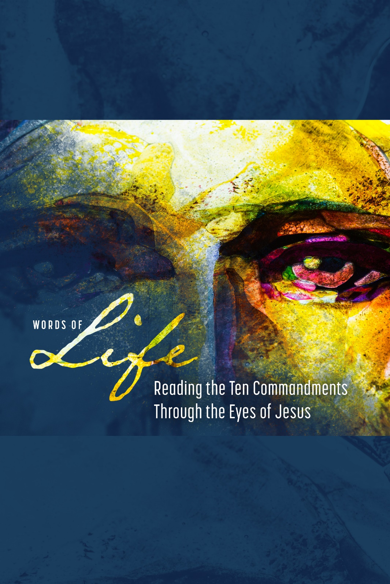

Bethel United Methodist Church

March 14, 2021
Knowing, Loving, Serving God
www.bethelumcrockhill.org
1232 Curtis Street, Rock Hill, SC 29730
Office Phone: 803.327.4881 Email: bethelrockhill@gmail.com
Pastor cell: 803.554.2298 Email: emilyscalessutton@gmail.com
Pianist Dena Wade
Administrative Assistant Becky Moon
Pastor Emily Sutton

ORDER OF WORSHIP
March 14, 2021
GATHERING
Prelude
Words of Welcome
Call to Worship
L: We gather to share in our love of God.
P: Lord, open our hearts and let us share your Good News.
L: We gather to share our witness to God’s goodness.
P: Lord, let our lives bear witness through service to your people.
L: We gather to praise God whose love is eternal.
P: Lord, open our hearts today to sing your praises. AMEN.

Opening Prayer
Lord, as we gather here, on this Sabbath day we pray that we may find rest in you. Renew our hearts, renew our minds, renew us oh Lord, so that we may be able to fully serve you. Remind us today that even you took time to rest and seek renewal. Guide us in our worship on this Sabbath day. In Christ’s Name, we offer this prayer. AMEN.
Special Music Take Time to Be Holy
*Affirmation Of Faith
I believe in God the Father Almighty,
Creator of Heaven and Earth.
I believe in Jesus Christ, His only son, our Lord,
Who was conceived by the Holy Spirit,
Born of the Virgin Mary,
Suffered under Pontius Pilate,
Was crucified, died and was buried;
He descended to the dead.
On the third day, He rose again;
He ascended into Heaven.
Is seated at the right hand of the Father,
And will come again to judge the living and the dead.
I believe in the Holy Spirit, the Holy catholic church,
The communion of saints, the forgiveness of sins, the
Resurrection of the body, and of life everlasting. AMEN.
Response: Gloria Patri Chris Wade

PROCLAMATION
Hymn This is Where Children Belong
Time With Children
Scripture Reading Matthew 11:24-12:14
Special Music I Love You, Lord
Scripture Reading Exodus 20:1-21
Sermon Sabbath: Rest, Renewal and Reverence Rev. Emily Sutton
RESPONSE
Prayers of the People
Lord’s Prayer
Our Father who art in heaven,
hallowed be thy name
Thy kingdom come,
Thy will be done,
on earth as it is in heaven.
Give us this day our daily bread.
And forgive us our trespasses,
As we forgive those who trespass against us.
And lead us not into temptation,
But deliver us from evil.
For thine is the kingdom, and the power, and the glory, for ever and ever. Amen.
Special Music Where He Leads Me I Will Follow
SENDING FORTH
*The Benediction
* The Postlude

