Updates and Announcements
Thank you for worshiping with us at Bethel United Methodist Church! We are delighted you have chosen to worship with us this morning.

This Week
Daily - Midday Community Holy Week Services at York Place each day 3/29 to 4/2 at noon.
Tuesday – Prayer Meeting at 9:30 am via Zoom
Lenten Book Study - Words of Life at 7pm via Zoom
Thursday - Maundy Thursday Service 4/1/21 at 6pm at Bethel.
Friday - Good Friday Service 4/2/21 at 6pm at Philadelphia.
Saturday – Easter Egg Hunt at PUMC at 10am
Sunday – Easter Sunrise Service at PUMC at 7am
Easter Service at 11:15am

Scan QR code to give electronically

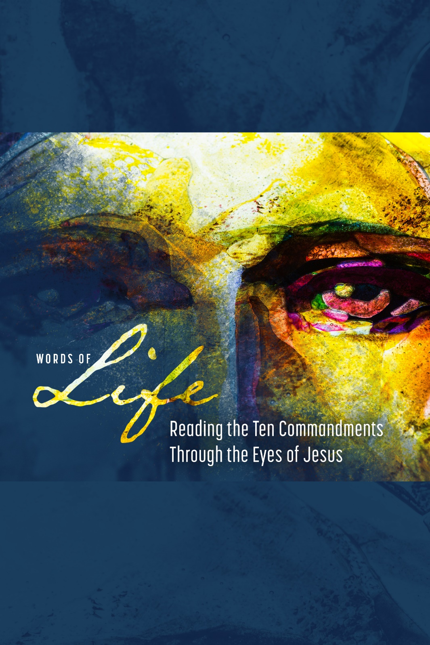

Bethel United Methodist Church

March 28, 2021
Knowing, Loving, Serving God
www.bethelumcrockhill.org
1232 Curtis Street, Rock Hill, SC 29730
Office Phone: 803.327.4881 Email: bethelrockhill@gmail.com
Pastor cell: 803.554.2298 Email: emilyscalessutton@gmail.com
Pianist Dena Wade
Administrative Assistant Becky Moon
Pastor Emily Sutton

ORDER OF WORSHIP
March 28, 2021
GATHERING
Prelude
Words of Welcome
Call to Worship
L: Jesus is coming!
P: From the mountainside, from the seaside, from the homes of the rich and the company of the poor, from the bedside of those who are sick
L: Jesus is coming!
P: Along dusty roads, with a ragged band of travelers, Jesus comes to Jerusalem, Jesus comes to worship.
L: Will we greet him with Hosannas?
Opening Prayer
We have come to meet you today, Jesus. We don’t know quite what to expect. We think we know what we need, how you can meet our needs. But we come humbly, laying our coats before you. It’s your call. Reveal to us who you are, how you can be a Savior in our lives, a Savior in our world today. Come Lord Jesus! Come! Amen.

Scripture Reading Mark 11:1-11
Special Music Hosanna Loud Hosanna
*Affirmation Of Faith
I believe in God the Father Almighty,
Creator of Heaven and Earth.
I believe in Jesus Christ, His only son, our Lord,
Who was conceived by the Holy Spirit,
Born of the Virgin Mary,
Suffered under Pontius Pilate,
Was crucified, died and was buried;
He descended to the dead.
On the third day, He rose again;
He ascended into Heaven.
Is seated at the right hand of the Father,
And will come again to judge the living and the dead.
I believe in the Holy Spirit, the Holy catholic church,
The communion of saints, the forgiveness of sins, the
Resurrection of the body, and of life everlasting. AMEN.
Response: Gloria Patri

PROCLAMATION
Hymn This is Where Children Belong
Time With Children
Scripture Reading Mark 15:1-39
Special Music Tell Me the Stories of Jesus
Scripture Reading Exodus 20:1-21
Sermon Do Not Kill Rev. Emily Sutton
RESPONSE
Prayers of the People
Lord’s Prayer
Our Father who art in heaven,
hallowed be thy name
Thy kingdom come,
Thy will be done,
on earth as it is in heaven.
Give us this day our daily bread.
And forgive us our trespasses,
As we forgive those who trespass against us.
And lead us not into temptation,
But deliver us from evil.
For thine is the kingdom, and the power, and the glory, for ever and ever. Amen.
Special Music All Glory Laud and Honor
SENDING FORTH
*The Benediction
* The Postlude

