Updates and Announcements
Thank you for worshiping with us at Bethel United Methodist Church! We are delighted you have chosen to worship with us this morning.

This Week
Tuesday – Prayer Meeting at 9:30 am via Zoom
Lenten Book Study - Words of Life at 7pm via Zoom

Upcoming:
Midday Community Holy Week Services at York Place each day 3/29 to 4/2 at noon.
Maundy Thursday Service 4/1/21 at 6pm at Bethel.
Good Friday Service 4/2/21 at 6pm at Philadelphia.

Scan QR code to give electronically

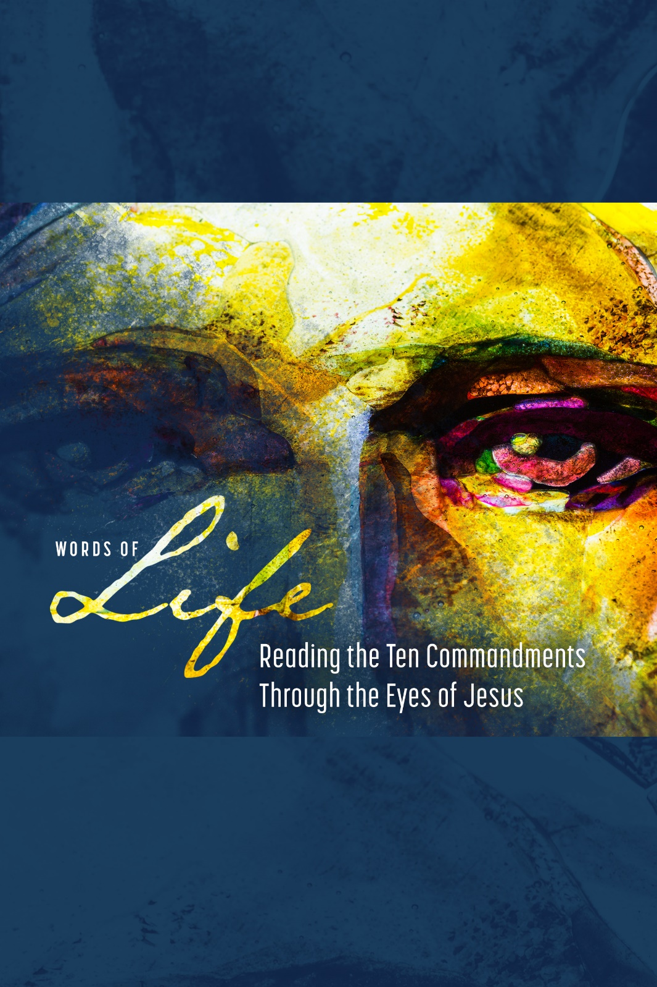

Bethel United Methodist Church

March 21, 2021
Knowing, Loving, Serving God
www.bethelumcrockhill.org
1232 Curtis Street, Rock Hill, SC 29730
Office Phone: 803.327.4881 Email: bethelrockhill@gmail.com
Pastor cell: 803.554.2298 Email: emilyscalessutton@gmail.com
Pianist Dena Wade
Administrative Assistant Becky Moon
Pastor Emily Sutton
ORDER OF WORSHIP
March 21, 2021
GATHERING
Prelude
Words of Welcome
Call to Worship
Leader: God’s love for us is great!
People: God is like a loving parent, who watches over us.
Leader: God’s mercy for us is great!
People: God reaches out to us in healing patience and peace.
Leader: Praise be to God who has called us here.
People: Praise be to God whose love and mercy is given to us. AMEN
Opening Prayer
We acknowledge you, O God, as creator and as liberator. You are the One who brought the captives out of Egypt and delivered them from the oppression of slavery. You gave laws which shaped how people were to relate to you, to each other. You asked us to worship only you, knowing that whatever was put in your place would become the priority of people's lives. Remind us today of your steadfast love revealed so clearly in the new commandment of love which Jesus disclosed with his life and, as we especially remember in this period of Lent, with his death. Speak to us anew as we offer this prayer and our worship in Jesus' name and for his sake. Amen.
Special Music Trust and Obey
*Affirmation Of Faith
I believe in God the Father Almighty,
Creator of Heaven and Earth.
I believe in Jesus Christ, His only son, our Lord,
Who was conceived by the Holy Spirit,
Born of the Virgin Mary,
Suffered under Pontius Pilate,
Was crucified, died and was buried;
He descended to the dead.
On the third day, He rose again;
He ascended into Heaven.
Is seated at the right hand of the Father,
And will come again to judge the living and the dead.
I believe in the Holy Spirit, the Holy catholic church,
The communion of saints, the forgiveness of sins, the
Resurrection of the body, and of life everlasting. AMEN.

Response: Gloria Patri Chris Wade

PROCLAMATION
Hymn This is Where Children Belong
Time With Children
Scripture Reading Matthew 15:1-9
Special Music
Scripture Reading Exodus 20:1-21
Sermon A Question of Honor Rev. Emily Sutton
RESPONSE
Prayers of the People
Lord’s Prayer
Our Father who art in heaven,
hallowed be thy name
Thy kingdom come,
Thy will be done,
on earth as it is in heaven.
Give us this day our daily bread.
And forgive us our trespasses,
As we forgive those who trespass against us.
And lead us not into temptation,
But deliver us from evil.
For thine is the kingdom, and the power, and the glory, for ever and ever. Amen.
Special Music Sweet Hour of Prayer
SENDING FORTH
*The Benediction
* The Postlude

